**Investigation into the Impact of Playing Strategy on Blackjack Outcomes**

Group members: Nathan Kistler

**Abstract**

**Background and Description of the Problem**

Blackjack is a game of strategy and chance that requires a player to take appropriate actions depending on the cards they are dealt. Doing so can assist a player in winning a higher percentage of games in the long run resulting in more money in the player’s pocket. In this project we tackle the impact implementing additional blackjack strategies has on the probability of a player winning the hand.

The game of blackjack is a simple game where the goal is to beat the dealer by getting a card count close to 21 without going over 21. A game starts by each player and the dealer being dealt two cards. The dealer reveals one of their cards allowing each player to make an educated decision as to hit (request another card) or stay. The basic strategy of blackjack is to only request a new card if the total of a player’s cards is less than 17. The card count is determined by the value shown on the card. Cards that show a number 2 through 10 are counted as the number shown, face cards (i.e., Jack, Queen, and King) hold a value of 10, and aces can either be 1 or 11 depending on the current player or dealer’s current situation. If a player is dealt a card with a value of 10 (i.e., a 10 or a face card) and an ace it said to be a “Blackjack” and the player automatically wins the hand.

In the game of black there are controlled variables that we cannot modify. For instance, the deck must consist of 52 cards that are drawn without replacement. Further it is assumed the deck is shuffled adequately so that the odds of drawing each card in the deck are equal and do not contain bias. In the current project we are assuming the player is not “counting cards”, if the reader is interested in learning about how this method can improve a player’s return please reference the 2008 movie, [21](https://www.imdb.com/title/tt0478087/). Although these assumptions lower the player’s overall odds of winning there are methods that can be used to improve a player’s odds.

There are legal methods to increase the player’s odds at winning. For instance, Figure 1 shows a table of the suggested actions depending on the player’s cards and the dealer card visible to the table. The basic strategy suggests a player should hit if the total of their cards is less than 17 and stay if the total of the cards is 17 or greater. However, it is clear there are more advanced strategies that are dependent on the situation at the table. An example is that the player should stay if the total of their cards is 13, 14, 15, 16 and the dealer’s visible card is between 2 and 6. Further there are times when a player can “split” their cards if dealt two of the same cards. Doing so allows a player to play two hands which can increase their odds of winning. In the present study we will take a subset of these more advanced strategies and investigate their impact on the simulated winning percentage.

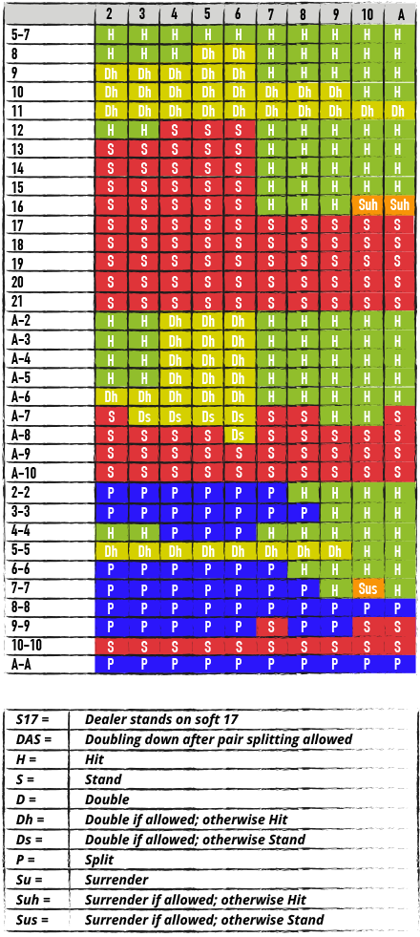

Figure . Table of blackjack strategies. Figure taken from *[1]*.

In this study I wanted to ensure enough of the more advanced strategies were used to obtain a statistically relevant result compared to the basic strategy while not inducing unnecessary complexity in the code. The additional strategies chosen can be seen below.

* Hit if a soft 18 (A + 7) and dealer’s visible card is 9, 10, Jack, Queen, King, or Ace
* Stay if dealer’s first card is less than a 6.

**Main Findings**

* Simulating the basic strategy
* Simulating the more advanced strategy
* Validation
* Comparing the results
* Explaining why it happened

**Conclusions**

The game of blackjack is a simple game where the goal is to beat the dealer by getting a card count close to 21 without going over 21. A game starts by each player and the dealer being dealt two cards. The dealer reveals one of their cards allowing each player to make an educated decision as to hit (request another card) or stay. The basic strategy of blackjack is to only request a new card if the total of a player’s cards is less than 17. There are more advanced concepts such as splitting cards when dealt a pair or adjusting the bet depending on the cards dealt. A list of several of these strategies can be found at the following link (<https://www.888casino.com/blog/blackjack-strategy/best-blackjack-strategies>).

For the current project I decided to code the simulation in Python. This was due to my comfort with the coding language and the available packages that would be useful for the problem at hand. For instance, numpy, matplotlib, and random have been used in the current version of the simulation. The work completed to date was to create a simulation of the most basic blackjack strategy (i.e., hitting until reaching 17). The work is compiled in a GIT repository (<https://github.com/natekist/GT-OMS/tree/main/IYSE%206644/Project/Group%2022%20-%20Blackjack>). The results are shown in the image below where the x-axis is the number of games simulated and the y-axis is the percentage of games won. As expected, the results are variable when the simulated number of games are low. The results hit a steady state ~42% as the number of simulated games increase. These results are consistent with the reported odds of winning at blackjack (<https://www.mrgreen.com/en/blackjack/strategies/blackjack-odds>).

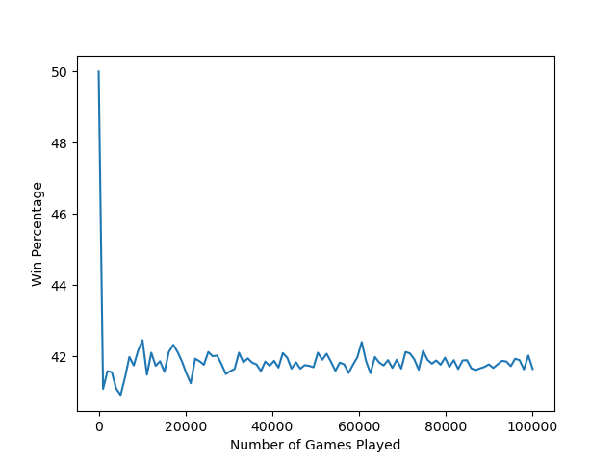

The next steps for the project are to introduce the additional strategies mentioned above. The win percentage after introducing the strategies will be compared to identify if using more advanced strategies will improve a player’s chance of winning.